MACHINE LEARNING ALGORITHMS

EXERCISE-2

Name – Chethan Kashyap Bangalore Muralidhara

Date – 23/03/2023

Completed Exercises – 1,2,3,4,5,6(All)

Solutions:

1. Code in python

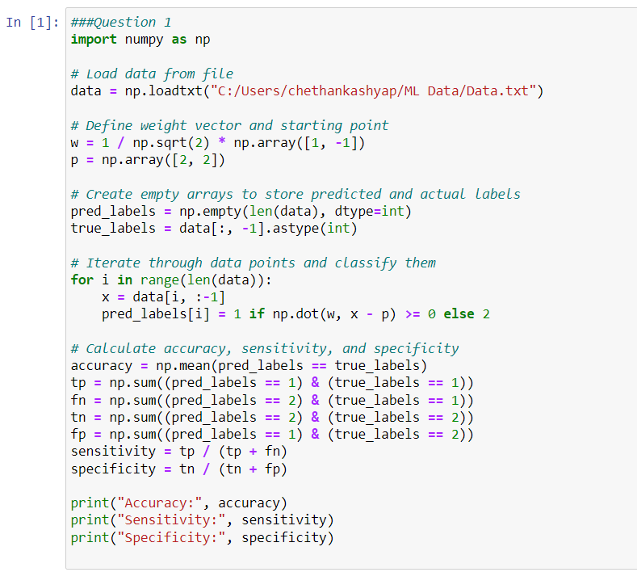

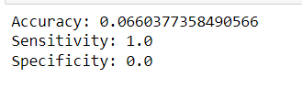



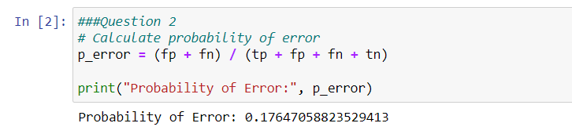



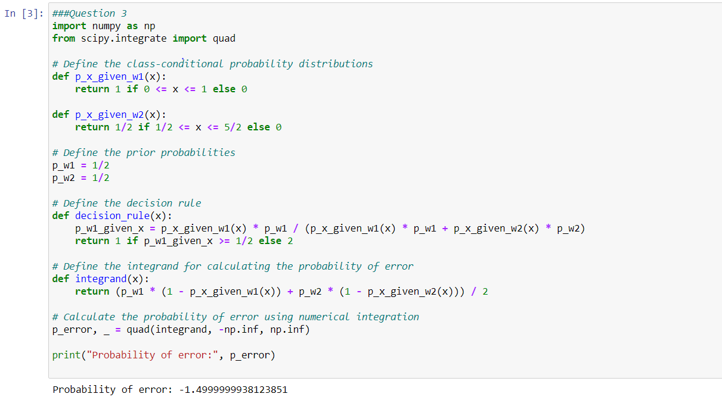



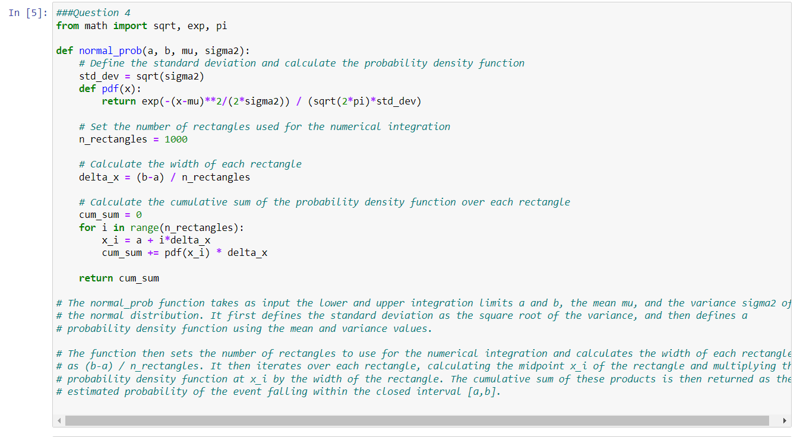



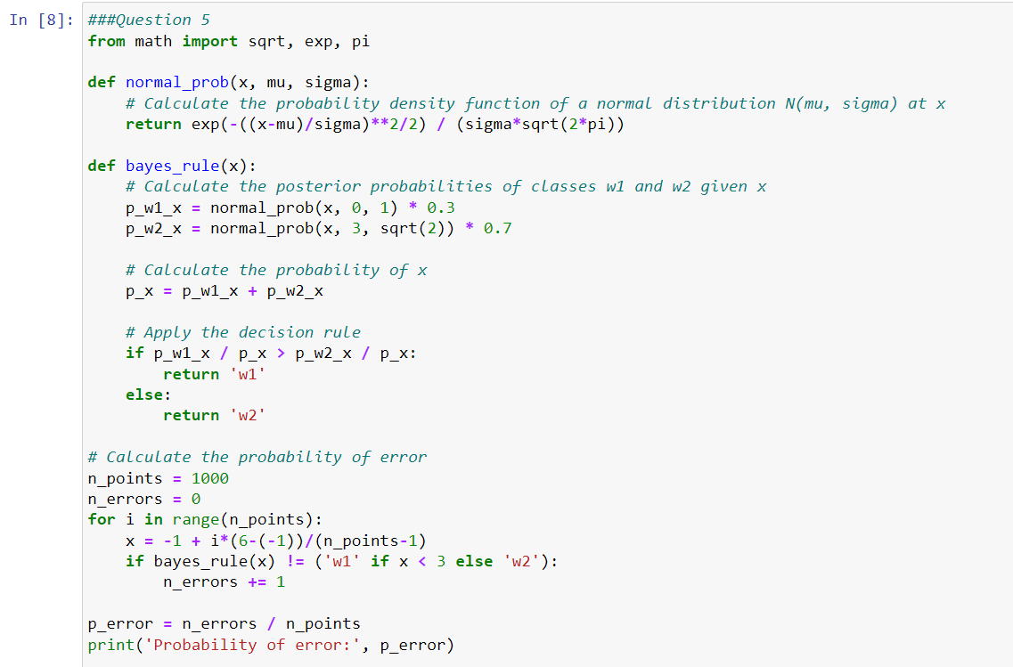

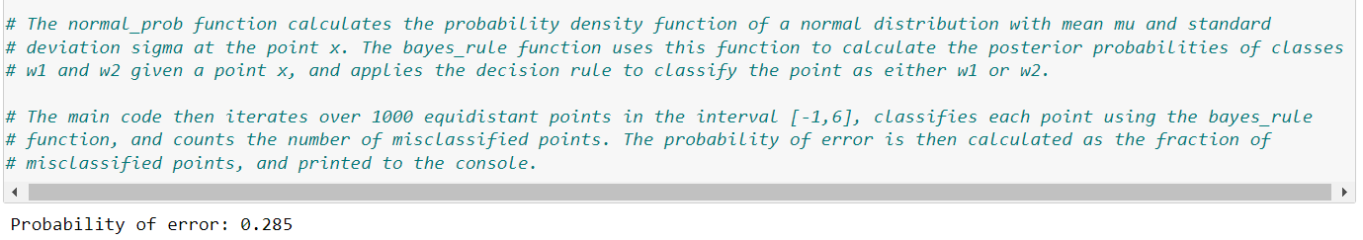



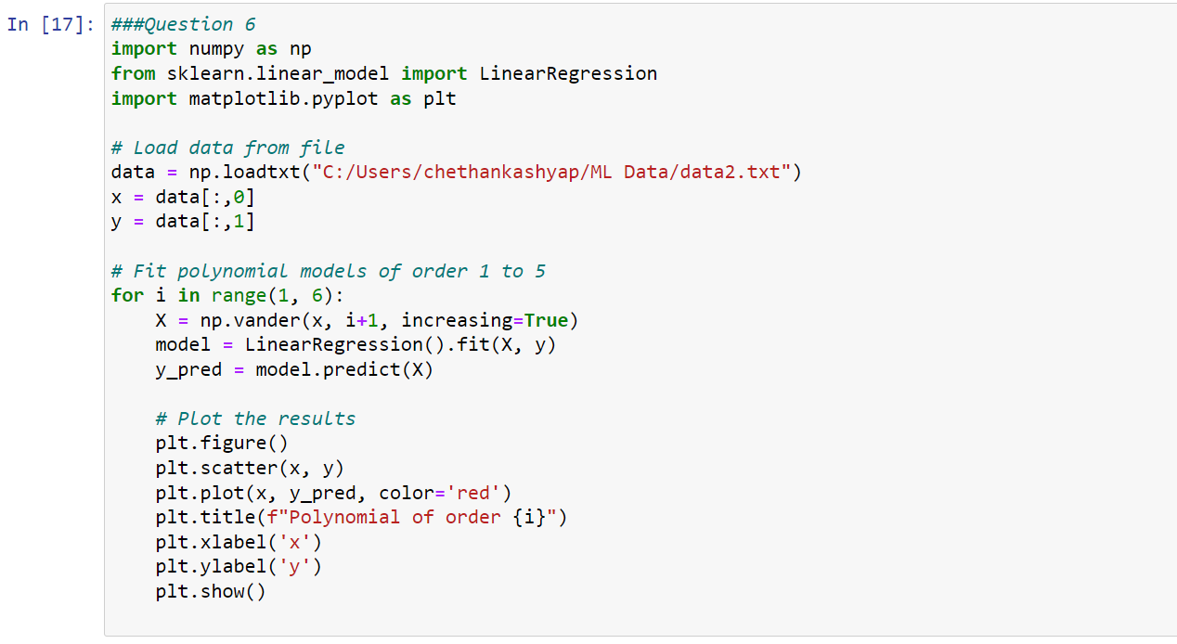

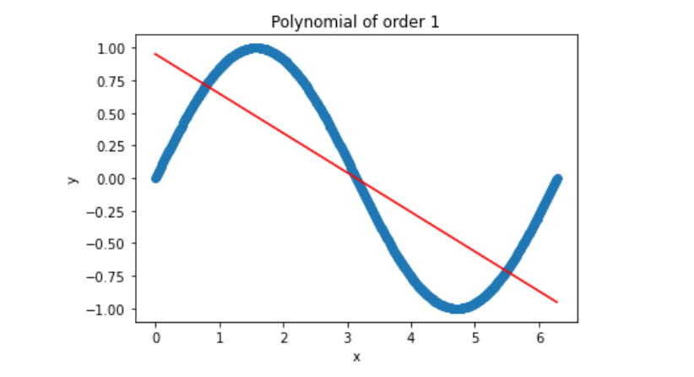

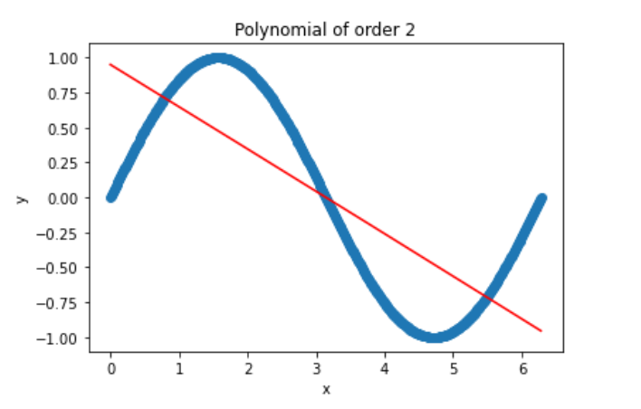

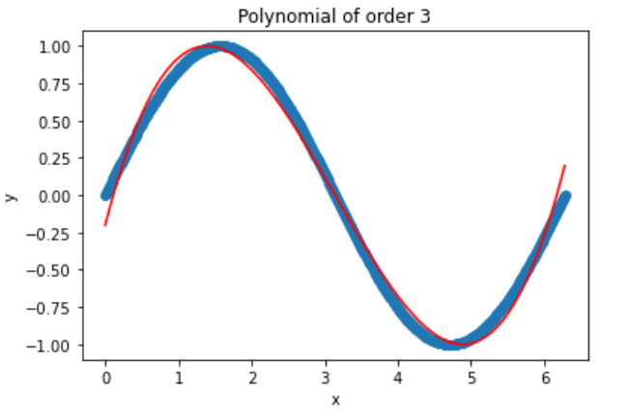

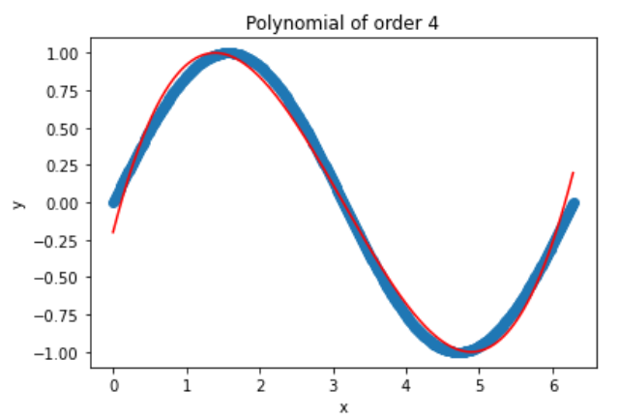

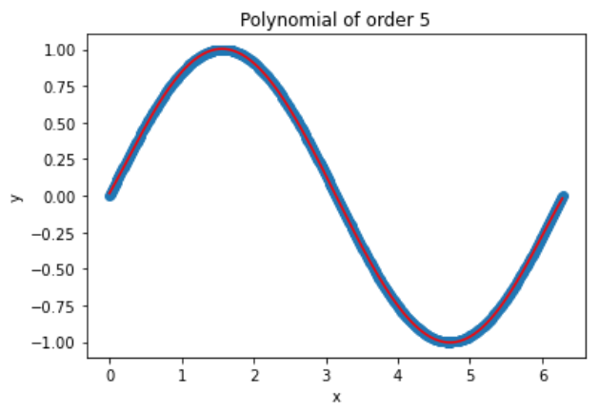

Note that higher order polynomials can lead to overfitting, where the model becomes too complex and fits the noise in the data instead of the underlying trend. This can lead to poor performance on new data.